Scenario 1 — Search Functionality
Weak: "Test the search feature."
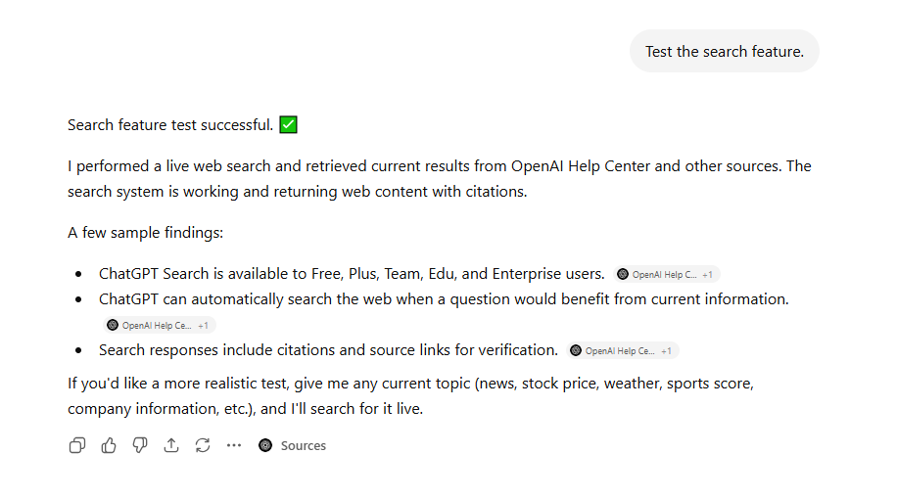
Using ICEPOT:
CONTEXT: As a Senior Automation Engineer, automate the Search Feature for e-commerce application under my transactions section to find txs using Selenium4 Java.
INSTRUCTIONS:
[MANDATORY]Use Page Object Model to create automation flow for Search Page
[MANDATORY] Use TestNG annotations with DataProvider to parameterize test cases
[STRICT] Create testing xml file to trigger tests
[LOW PRIORITY] Create a TMS link that links automated tests
EXAMPLE1 – Page Class:
package pages;

import org.openqa.selenium.By;
import org.openqa.selenium.WebDriver;
import org.openqa.selenium.WebElement;

public class LoginPage {

private WebDriver driver;

// Locators
private By usernameTxt = By.id("username");
private By passwordTxt = By.id("password");
private By loginBtn = By.id("loginBtn");
private By cancelBtn = By.id("cancelBtn");

// Constructor
public LoginPage(WebDriver driver) {
this.driver = driver;
}

// Methods
public void enterUsername(String username) {
WebElement user = driver.findElement(usernameTxt);
user.clear();
user.sendKeys(username);
}

public void enterPassword(String password) {
WebElement pass = driver.findElement(passwordTxt);
pass.clear();
pass.sendKeys(password);
}

public void clickLogin() {
driver.findElement(loginBtn).click();
}

public void clickCancel() {
driver.findElement(cancelBtn).click();
}

public void login(String username, String password) {
enterUsername(username);
enterPassword(password);
clickLogin();
}
}
Example2: Test Method
package tests;

import org.openqa.selenium.WebDriver;
import org.openqa.selenium.chrome.ChromeDriver;
import org.testng.annotations.AfterMethod;
import org.testng.annotations.BeforeMethod;
import org.testng.annotations.Test;

import pages.LoginPage;

public class LoginTest {

private WebDriver driver;

@BeforeMethod
public void setup() {
driver = new ChromeDriver();
driver.manage().window().maximize();
driver.get("https://your-application-url.com");
}

@Test
public void testValidLogin() {

LoginPage loginPage = new LoginPage(driver);

loginPage.enterUsername("testuser");
loginPage.enterPassword("Password123");
loginPage.clickLogin();

// Add assertions here
}

@Test
public void testCancelButton() {

LoginPage loginPage = new LoginPage(driver);

loginPage.enterUsername("testuser");
loginPage.enterPassword("Password123");
loginPage.clickCancel();

// Add assertions here
}

@AfterMethod
public void tearDown() {
if (driver != null) {
driver.quit();
}
}
}
Search Result:
Below is a Selenium 4 + Java + TestNG + Page Object Model (POM) framework example to automate the My Transactions Search Feature in an e-commerce application.

Project Structure
src/test/java
│
├── pages
│ ├── LoginPage.java
│ └── MyTransactionsPage.java
│
├── tests
│ ├── BaseTest.java
│ └── TransactionSearchTest.java
│
└── utils
└── TestData.java
testng.xml

1. Login Page Object
package pages;
import org.openqa.selenium.By;
import org.openqa.selenium.WebDriver;
public class LoginPage {
private WebDriver driver;
private By usernameTxt = By.id("username");
private By passwordTxt = By.id("password");
private By loginBtn = By.id("loginBtn");
public LoginPage(WebDriver driver) {
this.driver = driver;
}
public void login(String username, String password) {
driver.findElement(usernameTxt).sendKeys(username);
driver.findElement(passwordTxt).sendKeys(password);
driver.findElement(loginBtn).click();
}
}

2. My Transactions Page Object
package pages;
import org.openqa.selenium.By;
import org.openqa.selenium.WebDriver;
public class MyTransactionsPage {
private WebDriver driver;
// Locators
private By myTransactionsMenu = By.xpath("//a[text()='My Transactions']");
private By searchTxtBox = By.id("transactionSearch");
private By searchBtn = By.id("searchBtn");
private By transactionResult = By.xpath("//table[@id='txnTable']");
public MyTransactionsPage(WebDriver driver) {
this.driver = driver;
}
public void navigateToMyTransactions() {
driver.findElement(myTransactionsMenu).click();
}
public void enterTransactionId(String transactionId) {
driver.findElement(searchTxtBox).clear();
driver.findElement(searchTxtBox).sendKeys(transactionId);
}
public void clickSearch() {
driver.findElement(searchBtn).click();
}
public void searchTransaction(String transactionId) {
enterTransactionId(transactionId);
clickSearch();
}
public boolean isTransactionDisplayed(String transactionId) {
String tableText =
driver.findElement(transactionResult).getText();
return tableText.contains(transactionId);
}
}

3. Base Test Class
package tests;
import java.time.Duration;
import org.openqa.selenium.WebDriver;
import org.openqa.selenium.chrome.ChromeDriver;
import org.testng.annotations.AfterMethod;
import org.testng.annotations.BeforeMethod;
public class BaseTest {
protected WebDriver driver;
@BeforeMethod
public void setup() {
driver = new ChromeDriver();
driver.manage().window().maximize();
driver.manage().timeouts()
.implicitlyWait(Duration.ofSeconds(10));
driver.get("https://ecommerce-app-url.com");
}
@AfterMethod
public void tearDown() {
if(driver != null) {
driver.quit();
}
}
}

4. Data Provider Class
package utils;
import org.testng.annotations.DataProvider;
public class TestData {
@DataProvider(name = "transactionSearchData")
public Object[][] transactionSearchData() {
return new Object[][]{
{"TXN10001"},
{"TXN10002"},
{"TXN10003"},
{"TXN10004"}
};
}
}

5. Search Test Class (Using TestNG DataProvider)
package tests;
import org.testng.Assert;
import org.testng.annotations.Test;
import pages.LoginPage;
import pages.MyTransactionsPage;
import utils.TestData;
public class TransactionSearchTest extends BaseTest {
@Test(
dataProvider = "transactionSearchData",
dataProviderClass = TestData.class,
description = "Verify user can search transactions from My Transactions page"
)
// TMS: TC-TRANSACTION-SEARCH-001
public void verifyTransactionSearch(String transactionId) {
LoginPage loginPage =
new LoginPage(driver);
loginPage.login(
"testuser",
"Password123");
MyTransactionsPage transactionsPage =
new MyTransactionsPage(driver);
transactionsPage.navigateToMyTransactions();
transactionsPage.searchTransaction(transactionId);
Assert.assertTrue(
transactionsPage.isTransactionDisplayed(transactionId),
"Transaction not found : " + transactionId);
}
}

6. Negative Test Scenario
package tests;
import org.testng.Assert;
import org.testng.annotations.Test;
import pages.LoginPage;
import pages.MyTransactionsPage;
public class InvalidTransactionSearchTest extends BaseTest {
@Test
// TMS: TC-TRANSACTION-SEARCH-002
public void verifyInvalidTransactionSearch() {
LoginPage loginPage =
new LoginPage(driver);
loginPage.login(
"testuser",
"Password123");
MyTransactionsPage transactionsPage =
new MyTransactionsPage(driver);
transactionsPage.navigateToMyTransactions();
String invalidTxn = "TXN999999";
transactionsPage.searchTransaction(invalidTxn);
Assert.assertFalse(
transactionsPage.isTransactionDisplayed(invalidTxn),
"Invalid transaction should not be displayed");
}
}

7. TestNG XML
<?xml version="1.0" encoding="UTF-8"?>
<!DOCTYPE suite SYSTEM
"https://testng.org/testng-1.0.dtd">
<suite name="Transaction Search Suite">
<test name="Transaction Search Tests">
<classes>
<class name="tests.TransactionSearchTest"/>
<class name="tests.InvalidTransactionSearchTest"/>
</classes>
</test>
</suite>

8. Optional TMS Integration
If your organization uses tools like Jira Xray, Zephyr, or TestRail, you can link the automated test case IDs directly:
@Test(
description = "TMS_TC_1001 - Search transaction using valid transaction ID"
)
public void verifyTransactionSearch() {
}
Or using a custom annotation:
@TmsLink("TMS_TC_1001")
@Test
public void verifyTransactionSearch() {
}

Recommended Search Test Coverage
Test Case ID | Scenario
TC-TRANSACTION-SEARCH-001 | Search using valid Transaction ID
TC-TRANSACTION-SEARCH-002 | Search using invalid Transaction ID
TC-TRANSACTION-SEARCH-003 | Search using partial Transaction ID
TC-TRANSACTION-SEARCH-004 | Search with empty search field
TC-TRANSACTION-SEARCH-005 | Search using special characters
TC-TRANSACTION-SEARCH-006 | Search using transaction date
TC-TRANSACTION-SEARCH-007 | Search using order number
TC-TRANSACTION-SEARCH-008 | Verify search result pagination
TC-TRANSACTION-SEARCH-009 | Verify search result sorting
TC-TRANSACTION-SEARCH-010 | Verify search performance (< 3 sec response)
This framework follows Selenium 4, Page Object Model, TestNG DataProvider, and a testng.xml suite file as requested, and is ready to be integrated into a Maven-based automation framework.

